The Eyespy Package™
User manual v1.0

Content
Introduction……………………………………………………………………….1.1
Installation………………………………………………………………………..1.2
System Requirements…………………………………………………………..1.3
Functions of the application…………………………………………………….1.4
Error messages..……………………………………….………………………...1.5
Limitations…………………………………………….…………………………..1.6
Restoring the program……………………………..…………………………….1.7

  - Introduction
The Eyespy Package is a bundle of two separate and mutually independent applications. The applications are named Eyespy Core and Eyespy HQ, each have a different purpose.
Eyespy Core is a C# system tray icon program. It will run silently and presents no major user interface. Its purpose is to collect all the inbound HTTP traffic (websites the host computer visits), and extract the URL and keywords associated with the website. Via a PHP script hosted on a remote server, Eyespy Core uploads the URL and keywords to a database. While passing thought the PHP script, the URL is timestamped with two different time stamps: the first visit of the URL (or website) and the last visit. Websites are sorted into a database by category.

Eyespy HQ is a platform which allows the users to consult all the data collected from the host computer running Eyespy Core. The data is arranged into two types of analysis: data analysis and statistical analysis.
Data analysis displays data in the following manner: -

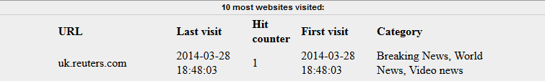

Statistical analysis, however, is a numerical analysis of the data, as shown below: -

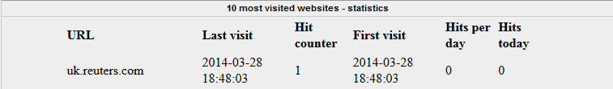

The Eyespy Package can be used by anybody who wishes to track their own browsing history or the browsing history of somebody on who they can exert the given authority (employees of an IT firm, young children).
This allows the user to track how the Internet is being used on the host-computer. This can be useful to maintain a standard of pedagogic usage of the Internet, for example.

Other users may be developers wishing to expand on the basic mechanics of Eyespy, with itss underlying statistical model, developers may be interested in integrating a more complex model of statistics for further analysis of browsing data, for this, developers can obtain the full source code by contacting calexcharles@gmail.com.

  - Installation -
No installation is required to use the Eyespy Core; the application will start running as soon as it is executed and until it is exited.
There is a small configuration required within the source code, however. Depending on if you are a developer or normal end-user, and wish to be in possession of the full source code or not, will depend on whether you need to have this configuration changed.

Standard users:-
1. For standard end-users, you will have been issued a fully functioning Eyespy Core executable ready for immediate usage.

When you launch the Core module, you’ll see this icon appear in the taskbar:
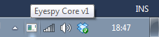
While this icon is present, Eyespy Core is running and processing data.

1.1 Logging into the Eyespy HQ will have been detailed to you by your issuer, with your personal HQ link and your chosen password.
Developers:-
2. If you are a developer, and you have obtained the full source code, there are a few modification required before you can start using the application.
2.1 As a developer, you will have been issued the Core and HQ source code, which means you will be required to set up Eyespy HQ on your PHP and phpmyadmin enabled webserver.
The first modification required is to be made inside the Eyespy HQ bundle. Open the Eyespy HQ folder, and then open the index.php file with your preferred text editor. On line 20 you will see the following line of code:
$mysqli = new mysqli("host", "user", "password", "eyespyhq");
Edit the “host”, “username” and “password” to match your own phpmyadmin connection credentials. This enables the Eyespy HQ to connect to your database platform.
2.2 Note that the exact same modification needs to be made in the “submit.php” file within the Eyespy HQ root.
The next step is to import the Eyespy HQ database so Eyespy Core can store data. To do this, open your phpmyadmin interface and import the database named “eyespyhq.sql”, which can be found within the root folder of the Eyespy Package.
2.3 Next, place the Eyespy HQ files on your webserver. Make note of the directory in which you’ve placed the “submit.php” file.
2.4 Finally, open Eyespy Core Visual Studio Solution file, and within the “HTTPWriter.cs” file you’ll see the following line of code:
HttpWebRequest request = (HttpWebRequest)WebRequest.Create("http://www.charlesnet.info/eyespy/submit.php");
Edit the “charlesnet.info/Eyespy” to fit the directory where you placed the abovementioned Submit.php file.

To access Eyespy HQ, open your browser and navigate to the root directory where you uploaded the HQ files. The default logon password is “admin” but can be changed inside the logon SQL table imported earlier.

2.5 You’ll also need to modify
sock.Bind(new IPEndPoint(IPAddress.Parse("172.16.14.216"), 80));
"172.16.14.216" Will need to be the IPv4 address of the host machine.
You can get this by opening cmd and entering the netstat command.

The Eyespy package is now fully usable.

  - System Requirements
System requirements (minimum)
Minimum hardware requirements:
Disk space: 50mb
CPU: Intel or AMD 1Ghz
RAM: 512mb
Software requirements:
Windows computer
.NET Framework 4.0 (can be downloaded from Microsoft.com)
Software requirements for developer package:
Webhost with PHP and phpmyadmin capability.

  - Functions of the Application –
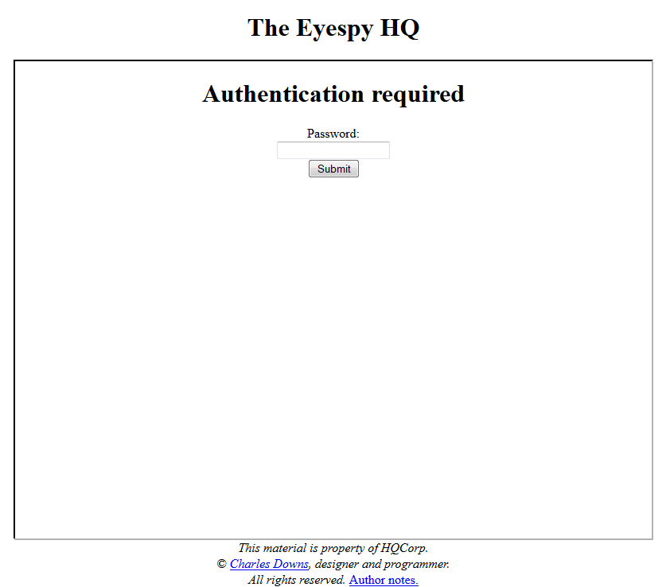
Logging in

First, you’ll need to navigate to the Eyespy HQ URL provided to you, or the URL where you’ve placed Eyespy HQ on your webserver, if you’re a developer.
Input the password that was either supplied to you or the one that you have chosen.
Next, proceed by clicking the submit button.

Data analysis
Figure 1 shows the main Eyespy HQ design. As can be seen, the interface is split into 3 different tabs, each having different functions. The first tab, “Data analysis” allows users to analyse input data via factual information regarding the site. Such information is illustrated in Figure 1.
Each tab of data is further divided into two different analysis points: top 10 and last 10. These two tables of data are within the collapsible panels, entitled “10 most visited website” and “Last 10 visited websites”. By clicking on these titles, the panel will expand or collapse to reveal or hide the data.
Figure 1
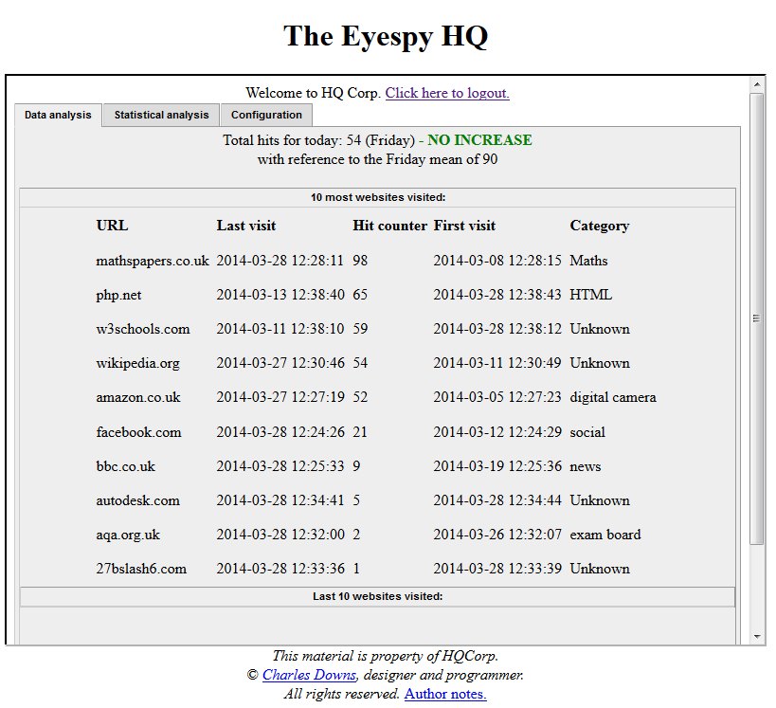

Statistical analysis
Figure 2 illustrates the second tab, “Statistical analysis” which allows the user to analyse the data from a more numeric and statistical point of view, with data such as “Hits per day” and “Hits today”.
Just like in the Data Analysis tab, both tables of data are subdivided into two different tables, top 10 and last 10.

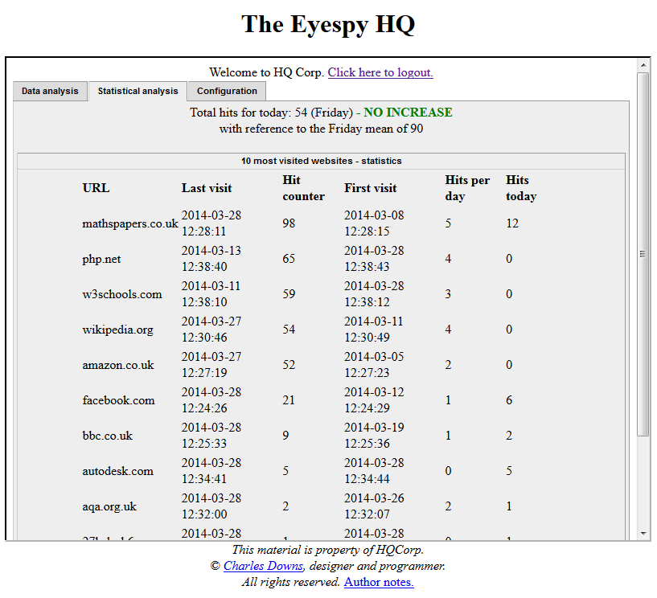
Figure 2

General increase or decrease
The header of both statistical and data analysis present the following text -
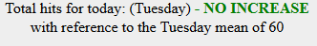
This is a general calculation of whether the average website hits for the day has increased or not. Comparing these hits for the average amount of hits stored in the database either gives a green NO INCREASE or a red INCREASE.

These values are configurable within the database “staticStatistics” table – for developers you may wish to set these values manually, for standard end-users these values will have been set for you upon purchase.

Configuration
Finally, the “Configuration” tab can be used to reset the hitcounters of every website, delete all categories from the database, or delete all website entries.
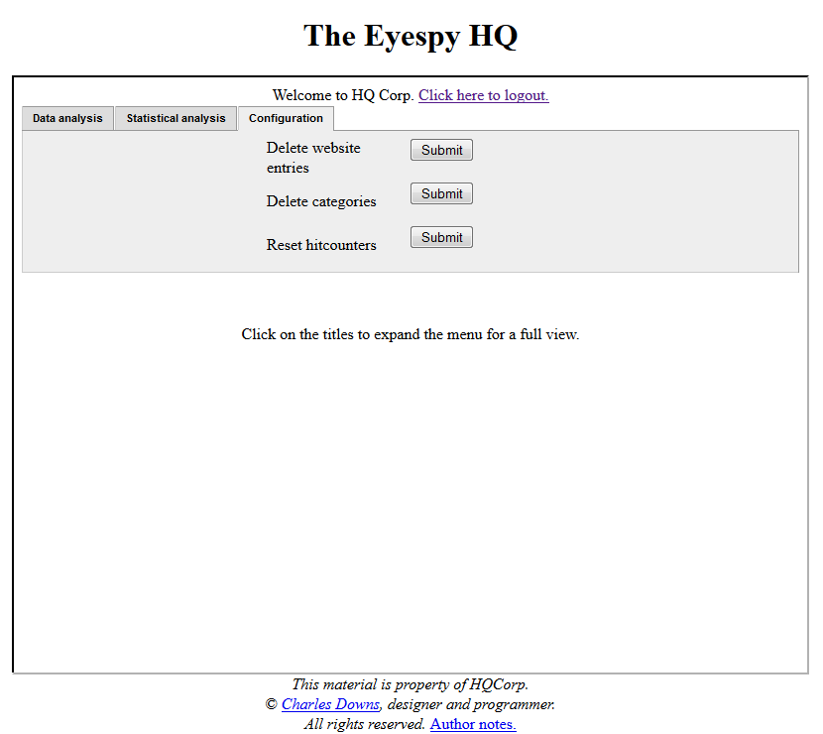
Figure 3
Logging out
⬅ Use the hyperlink

Contacting the developer
⬅Use the hyperlink

Using the Core module.
The core module presents no real UI, the only visible interface is the tray icon:
Eyespy tray icon

A single-item context menu can be viewed by right-clicking on the icon:
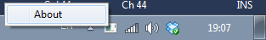

Clicking the “About” item gives the status of the URL-related variable:
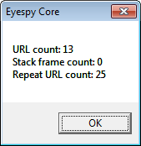

  - Error messages -
Eyespy Core will display no error messages, as it runs as a hidden process on a host machine. It is designed so the person using the host machine does not have to interact with it, or even know that it is there.
For developers, the only message that may occur is the following:-
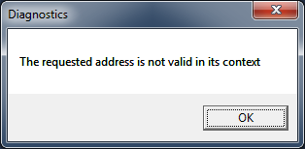
This occurs when section 2.5 of the installation has not been done.
The only error message that can occur when using Eyespy HQ will be displayed when a connection cannot be established to the database: “Error- Cannot connect to MySQL.” In the unlikely event of this message occurring, you should contact your Eyespy issuer and explain the situation.

  - Limitations
Eyespy currently presents no limitations in its functionality, there are however a few issues with data that it collects.
Most websites have separate image servers and advertisement servers, unfortunately, Eyespy recognizes these URL’s as inbound traffic, which means it will collect and store them, which is problematic as the links are not relevant to the actual browsing history.

  - Restoring the program –
In the even of program failure, or loss of the software though hard-disk corruption, see the following and read the one that best describes your situation –
Developer –
No data collected by Eyespy has been lost, as it is stored on your remote server. You will have to re-download the software from the URL provided to you by the software issuer via the email you were sent, the only modification you have to make is regarding the Eyespy Core module – see section 2.4 of the Installation instructions.
End-users –
No data collected by Eyespy has been lost, you will still be able to access all collected data via your logon and the HQ link provided to you. You will, however, have to re-download the Eyespy Core via the URL provided to you in the email sent by your software issuer. Once you’ve downloaded it, you can resume usage as before by opening the executable file.

